Brussels, 24 of August 2022

Dear Members of the European Council of Literary Translators’ Associations (CEATL), dear Translators:

The European Writers’ Council (EWC) has launched the #Freeallwords translation project to support Ukrainian and Belarusian writers who continue to work in resistance to the ongoing Russian offensive in Ukraine and the ongoing government-led attack on fundamental freedoms in Belarus. The main goal of the Foundation-funded project is to provide a platform for authors to write about the tragic events in Eastern Europe and to make their voices heard in societies where war, human rights abuses, and dictatorship are unknown.

All translated works will be published on https://freeallwords.org. We plan to have about 100 works (prose, essays, interviews, poems) translated into European languages without favoring one language over another. We aim to encourage media and other entities to assist in promotion and dissemination of the works translated within our project. Translators’ associations are also invited to publish translated texts. The names of the authors and translators are mentioned for each publication. The copyright of the translation remains within the translator; the project will have only non-exclusive rights. Both authors and translators are paid by the funds.

Our goal is to give writers the opportunity to speak out and be heard despite all the horrors of war and repression, and to help European audiences learn more about Belarus and Ukraine through the power of art, culture and words. We began accepting applications for texts on July 14 of this year. The first works are already being considered for translation.
But without a translator, no translation project can exist!

We are now inviting translators of CEATL organisations, who work with one or more languages used by Belarusian and Ukrainian authors: Belarusian, Ukrainian and Russian, to register for the project #FreeAllWords.

We would be grateful if you would participate in our project. If you want to register, please send a confirmation e-mail to Alena Makouskaya and Aliaksandra Dvaretskaya under contact@freeallwords.org with the subject "Translator”. Please include a short CV, a picture (jpeg) with copyright reference (name of photographer), some titles you have translated and a website (e.g. your homepage or your member profile of your translators' associationRegistered translators will be listed as an official translator of #FreeAllWords on the project homepage, and step by step also presented on the Social Media Accounts (Facebook, Twitter).

Finally, we would like to inform about the financial conditions: 0.20 EUR per word of translated prose and 0.30 EUR per word of translated poetry, plus the national VAT. The translation agreement provides for non-exclusive use within the framework of the project. No other rights are transferred by it. After publication on the website, the text will be made available to literary organisations and media. The right of reuse remains the property of the translator. Should publishers wish to use the text, the author and translator must be asked to grant the rights again in exchange for a fee to the author and translator.

If you have questions or concerns, please do not hesitate to contact us. We are looking forward to your reply! Together we will make the voices of Ukrainian and Belarusian authors heard.

With our warmest regards:
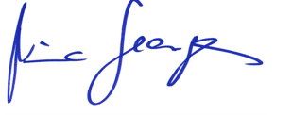
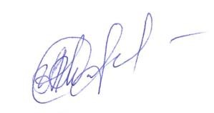

Alena Makouskaya Nina George
EWC Board Member President of the EWC
#FreeAllWords

